Report for: | Planning Policy Advisory Panel
Date of Meeting: | 30 November 2022
Subject: | Outcomes of consideration of three areas for Conservation Area Status
Key Decision: | No (information report only)
Responsible Officer: | Viv Evans, Chief Planning Officer
Portfolio Holder: | Councillor Marilyn Ashton, Deputy Leader of the Council, Planning & Regeneration Portfolio Holder
Exempt: | No
Decision subject to Call-in: | No
Wards affected: | West Harrow, Harrow Weald, North Harrow
Enclosures: | Appendix 1 - maps of areas to be considered for conservation area status.  Appendices 2-4 – supporting material for Butler Avenue (2), West Drive Gardens, Bellfield Avenue and West Drive numbers 1- 41 (odd) and 2-36 (even) in Harrow Weald (3) and Suffolk Road (4)

Section 1 – Summary and Recommendations
This report documents the outcomes of the assessment of the following three areas (shown in Appendix 1) for potential designation as conservation areas:

(i) Butler Avenue and surrounding roads in West Harrow (map 1),
(ii) West Drive Gardens, Bellfield Avenue and West Drive numbers 1- 41 (odd) and 2-36 (even) in Harrow Weald (map 2), and
(iii) Suffolk Road in North Harrow (map 3).

The Panel considered the intention to assess these areas for potential designation at its meeting on 3 October 2022.

The subsequent assessments concludes that Butter Avenue (West Harrow) and Suffolk Road (North Harrow) do not meet the Harrow criteria for designation. West Drive Gardens, Bellfield Avenue and West Drive numbers 1- 41 (odd) and 2-36 (even) (Harrow Weald) is marginal.

Recommendations:

The Planning Policy Advisory Panel is requested to: consider the outcomes of the assessment of the areas to be considered for conservation area status and provide any comments.

Reason:
Conservation Areas are designated under the Planning (Listed Buildings and Conservation Areas) Act 1990 (‘the Act’) which states in section 69 that 'every local planning authority shall from time to time determine which parts of their area are areas of special architectural or historic interest the character or appearance of which it is desirable to preserve or enhance, and shall designate those areas as conservation areas'. Consideration of the three areas as possible conservation areas therefore fulfils Section 69 of the Act.

Section 2 – Report

1.0 Introduction

1.1 The report incorporates the corporate priority concerning:
- Putting Residents First

1.2 Should the areas meet the criteria for conservation area status, the improved protection of identified areas of special architectural or historic interest will help maintain the unique historical local character of areas or neighbourhoods within Harrow which residents cherish and value.

2.0 Options considered

2.1 The option of not reviewing these areas was considered but this would be contrary to the Council’s statutory obligations under the Planning (Listed Buildings and Conservation Areas) Act 1990, under which local planning authorities are required to carry out reviews ‘from time to time’ to ensure areas are adequately protected.

2.2 Paragraph 3.8 below identifies an alternative option to designation as a conservation area, should the assessments determine an area does not meet the requirements to be designated a conservation area.

3.0 Background

What is a conservation area?

3.1 As noted in the report to the Panel on 3 October 2022, Conservation Areas are designated under the Planning (Listed Buildings and Conservation Areas) Act 1990 which states in section 69 that 'every local planning authority shall from time to time determine which parts of their area are areas of special architectural or historic interest the character or appearance of which it is desirable to preserve or enhance, and shall designate those areas as conservation areas'.

3.2 Harrow has adopted four Supplementary Planning Documents (SPDs) that cover the borough’s existing conservation areas. Those documents include local guidance as to what is considered to represent ‘special architectural or historic interest’ in the Harrow context. In order for an area to be appropriate designation as a conservation area, it must fulfil two of the following criteria (as outlined in the SPDs):

(a) Areas with a high concentration of Listed Buildings, whether statutorily or locally listed;
(b) Areas of historical, social, economic and/or architectural merit;
(c) Areas with a high proportion of buildings built prior to 1920, which remain largely unaltered;
(d) Areas built post 1920 that are innovative in planning or architectural detail, and where a large proportion remain unaltered;
(e) A significant group of buildings with distinct physical identity and cohesiveness;
(f) Areas which have a special quality, where the site layout and landscaping are of exceptionally high quality and/or contain historic open space, natural landmarks, topographical features or features of local distinctiveness

When not to designate?

3.3 The National Planning Policy Framework (NPPF) (2021) states in paragraph 191 that:

‘When considering the designation of conservation areas, local planning authorities should ensure that an area justifies such status because of its special architectural or historic interest, and that the concept of conservation is not devalued through the designation of areas that lack special interest’.

3.4 Historic England are the Government’s advisers on matters of heritage. They have published guidance entitled: ‘Conservation Area Appraisal, Designation and Management Historic England Advice Note 1’ [HEAN 1] (Second Edition) – February 2019. They highlight the above requirement of the NPPF twice in their guidance since it was also contained in earlier iterations of the NPPF.

3.5 In addition, HEAN1 mirrors the requirements of s.69 of the Act that there shall be both ‘special interest’ and ‘desirability to preserve or enhance’ for CA designation as it states in paragraph 11 that there is: ‘likely to be a stage when a decision would need to be taken as to the significance of an area and the likelihood of conservation area designation addressing relevant problems within the area. This is unlikely to be a lengthy process, the purpose being to consider whether an area has:
a) sufficient architectural or historic interest for the area to be considered ‘special’?
b) whether this is experienced through its character or appearance? and
c) whether it is desirable for that character or appearance to be preserved or enhanced, and what problems designation could help to solve’.

3.6 Thus, it indicates that where an area meets the criteria for designation, on occasion designation may not be desirable and prompts consideration as to what problems designation could help solve in order to determine the desirability of designation.

Alternatives to Conservation Area designation

3.7 Conservation Areas are a heritage designation governed by national legislation and the principle of what makes an area ‘special’ needs to be considered in the national context; it is therefore a high threshold. Conservation area designation also reduces permitted development rights (i.e. what can be done without planning permission). At a local level, unlike many Local Planning Authorities, Harrow currently does not have a local form of area designation based on the architectural and / or historic interest of an area (a similar concept to Harrow’s ‘Local List’ of buildings compared to statutory listed buildings, which are designated at a national level).

3.8 Depending on the outcomes of the assessments proposed in this report, an option for any area/s considered not to meet the requirements to be designated a conservation area could be for those to be formally identified as having local architectural and / or historic interest. This would not change permitted development rights but would be a material consideration for any planning applications that are received within the area. Such a potential local approach would be developed further and reported in any subsequent report to the Panel as appropriate. Such an approach could also be potentially applied to other areas in the borough. As advised verbally at the last Panel meeting, the suggested name of such a designation is ‘Local Area of Special Character’.

4.0 Outcomes of the assessment of the proposed areas

4.1 The three areas that were considered for designation as conservation areas are shown in Appendix 1 and are as follows:

- Butler Avenue and surrounding roads in West Harrow (map 1)
(b) West Drive Gardens, Bellfield Avenue and West Drive numbers 1- 41 (odd) and 2-36 (even) in Harrow Weald (map 2), and
(c) Suffolk Road, North Harrow (map 3).

4.2 These areas have been identified by the Planning & Regeneration Portfolio Holder based on requests from residents within the areas.

4.3 The assessments have been undertaken as follows:

- Local history research (local history library, online, consulting any local resident/heritage groups).
- Identification of existing heritage assets (Council records).
- Site visit (including photo survey) to document relevant matters such as: architectural styles, original features apparent e.g. windows, changes apparent, front garden greenery, boundary treatments.
- Assessment of the outcomes of (a) - (c) above against the national and local criteria for Conservation Areas.

4.4 Sections 5-7 below document the outcomes of the research and assessment of each area against the criteria identified in paragraph 3.2 above.

5.0 Butler Avenue, West Harrow

Research

5.1 An area to research was identified based on the initial area identified and the discussion at the Panel meeting on 3 October 2022. The area is shown in Appendix 1 (Map 1) and included Butler Avenue (all), Butler Road (all), Bessborough Road (24-42 – even), and Vaughan Road (1-55 – odd).

5.2 A site visit and photo survey was then undertaken, along with local history research relevant to the possibility of the area being designated a conservation area. Appendix 2-A is an OS map regression. Appendix 2-B is a representative selection of photos.

5.3 Local History research produced the following findings:

- The roads form part of a wider area known as the Bessborough Estate, West Harrow. The part that is subject of investigation began being developed in 1898. It was open green fields of Honeybun Farm owned by the Atkins family. The streets built included Butler Road, Butler Avenue, Sumner Road, Drury Road named after Harrow School’s former headmasters and masters. Butler Avenue (founded 1898 and part of Butler Road 1898-1905) and Butler Road (founded 1898) were named after one of the Harrow School Headmasters, George Butler (1805-1829) or H Montagu Butler (1860-1885). The last house was built in Butler Avenue was in 1999. The building of houses in Butler Road had finished by 1925 at the latest. Vaughan Road (founded 1898) was named after Charles John Vaughan, Headmaster of Harrow School from 1846-1859 with the last houses constructed within (2B, 2C, 2D and 2E) having been built in 2008.
- Sir Roger Banister lived at 77 Butler Road.
- An early photograph of Butler Avenue is included as Appendix 2-C. Comparing with present day, indicates the range of alterations e.g. loss of original boundary treatments and replacement windows.

Does Butler Avenue and surrounding roads meet the criteria?

5.4 This is addressed as follows in relation to each of the criterion listed in paragraph 3.2 above:

- Areas with a high concentration of Listed Buildings, whether statutorily or locally listed – This criterion is not met. 40 and 42 Bessborough Road are locally listed. A local list description is enclosed at Appendix 2-D. This is not a high concentration of locally listed buildings.

- Areas of historical, social, economic and/or architectural merit – marginal. Local history research did not identify anything of significant note about this or surrounding streets although it did yield the historic OS maps in Appendix 2-A and shown that the streets (as per some outside the study area) were named after school masters at Harrow School and that Sir Roger Bannister once lived at 77 Butler Road.

Butler Avenue and surrounding roads have some historic and architectural merit being streets of terraced, and closely spaced detached, late Victorian / Edwardian and otherwise early 20th century Metroland, two storey houses of similar scale in tightly spaced linear plots on a tree lined street. These were built after the development of the Metroland railway including Harrow on the Hill station to the north. There is a pleasing consistency in most areas to the gable ends and chimneys in the roofscape, particularly notable along Butler Road, Vaughan Road and parts of Butler Avenue.

Along Butler Avenue along the eastern end there is pleasant decorative gauged red brick detail particularly in some gable ends (with dentil courses) and above windows, and porches with decorative carved timber detail and clay tiles. Occasional delicate timber sash multi-paned windows remain and multi-panelled front doors on selected buildings. 32-36 Butler Avenue have distinctive applied timber detail and double fronted character albeit all with replacement concrete tiled roofs.

The wider surrounding streets houses similarly have some individual decorative features remaining including:

- carved timber porches
- good brickwork patterns in the form of gauged brick arches above windows and dentil courses, brickwork aprons
- multi-paned timber sash windows and multi-panelled front doors
- bay windows
- tile hanging
- black and white timber detailing.

However, almost all building frontages are unsympathetically altered. The overwhelming majority have unsympathetic: replacement windows, concrete tiles, hard-surfaced front gardens, rendered over or pebbledashed brickwork of various colours, painted brickwork frontages, decorative gable ends covered over with various plain modern applied finishes. Even the two locally listed buildings 40-42 Bessborough Road have not escaped this treatment, having their decorative gable ends covered over and original timber windows replaced with harmful plastic ones (Appendix 2-E shows before and after). This significantly harms any original architectural and historic interest, providing a patchwork character of harmful alterations.

- Areas with a high proportion of buildings built prior to 1920, which remain largely unaltered - This criterion is not met. Whilst some buildings were built before 1920, the overwhelming character is that of a patchwork of harmful alterations identified in paragraph 5.4 part (b) above.

- Areas built post 1920 that are innovative in planning or architectural detail, and where a large proportion remain unaltered – This criterion is not met. Whilst some buildings were built after 1920 they display no innovation in planning or architectural detail and in any case a large proportion have altered as noted above.

- A significant group of buildings with distinct physical identity and cohesiveness – This criterion is not met. There is some physical identity and cohesiveness due to it being possible to group them according to their all being streets of terraced, and closely spaced detached, late Victorian / Edwardian and otherwise early 20th century Metroland, this is no different to surrounding similarly altered streets of residential houses. There are far better-preserved examples in wider London.

- Areas which have a special quality, where the site layout and landscaping are of exceptionally high quality and/or contain historic open space, natural landmarks, topographical features or features of local distinctiveness – This criterion is not met. The site layout is that of a typical residential street and there is either no landscaping at all or simply typical tree lining to the street or small front garden soft landscaping.

2014 report

5.5 Local history research identified that Butler Avenue was last inspected for conservation area status in 2014 following receipt of a councillor enquiry at that time. . This reinforces the findings of this current assessment as it similarly concluded the criteria for conservation area status were not met.

Conclusion and recommendation- Butler Avenue (West Harrow)

5.6 Based on the site and photographic survey, local history search and consideration of the criteria for designating a conservation area, it is concluded that the area should not be designated a conservation area.

5.7 Like many residential areas in Harrow, Butler Avenue and surrounding roads have limited historic and architectural merit, being streets of generally pleasant largely early 20th century terraced (and some detached) houses of similar scale in tightly drawn plots.

5.8 Nevertheless, they are highly altered with creating an overwhelming patchwork character and appearance of unsympathetic replacement / alteration works. Local history research and a site visit did not pick out any part of its historic development, architecture, history or landscape to distinguish the area as an area of ‘special architectural or historic interest the character or appearance of which it is desirable to preserve or enhance’.

5.9 Notwithstanding the marginal interest that come with being streets of largely early 20th century houses with some decorative features remaining, and the fact that streets (like other surrounding ones) are named after former Masters at Harrow School and Sir Roger Banister once living in the area, the criteria for conservation area status are not met. Designation would run contrary to the criteria for designation and the requirement of the NPPF and Historic England to not devalue the concept of a conservation area by designating areas that are not worthy.

6.0 West Drive Gardens, Bellfield Avenue and West Drive numbers 1- 41 (odd) and 2-36 (even), Harrow Weald

Research

6.1 An area to research was identified based on the initial area identified and the discussion at the Panel meeting on 3 October 2022. The area is shown in Appendix 1 (Map 2) and included West Drive Gardens, Bellfield Avenue and West Drive numbers 1- 41 (odd) and 2-36 (even), Harrow Weald.

Previous surveys

6.2 The area was subject to two assessments in 1989 and 1990, which concluded the streets did not warrant designation as a conservation area. It should be noted that 51-71 (odd) and 40-50 (even) West Drive have been included in a conservation area since 1979. This was subsequently extended to include: North Lodge (locally listed) and the Eagles (locally listed) on Brookshill in 1991.

6.3 In 2006, the Council’s Conservation team was requested to consider the merits of extending West Drive Conservation Area (as described in paragraph 6.2 above) to include the remainder of West Drive (south from the existing conservation area to Uxbridge Road), as well as West Drive Gardens and Bellfield Avenue. This was in response to local residents’ requests.

6.4 Research took place into the proposed conservation area streets including: an on-site survey of the area (percentage of uPVC windows, percentage of hard-surfacing, percentage properties with extensions/alterations visible from the highway, and boundary treatments used), photographs, Building Control records, local history library research and minutes from previous Harrow Council meetings. Maps were considered to identify: historical data; Tree Preservation Orders; green belt land; areas of special character; scheduled ancient monuments; green corridors; regionally important geological sites; archaeological priority areas and historic parks and gardens.

6.5 A report was put forward to the former Local Development Framework Advisory Panel (30 November 2006) where the panel were invited to discuss the report regarding the proposed extension.

6.6 The report was not specific as to whether the area met any criteria for conservation area status and concluded that the case for designation was marginal. The Panel were invited to make a recommendation on this matter to the Portfolio Holder for Planning Development and Enterprise. The minutes of the meeting noted:

Some Members of the Panel expressed the view that the area was a ‘borderline’ case, comprising a mixture of 1920s and 1930s housing and later ‘infill’ properties, however, the 1920s properties presented a significant feature and, being nearly one hundred years old, would benefit from protection to preserve the character of the area.

6.7 After discussion it was resolved to recommend the extension of the conservation area, which was implemented by way of Portfolio Holder decision on 17December 2006.

6.8 Section 71 of the Planning (Listed Buildings and Conservation Areas) Act 1990 requires Local Planning Authorities to from time to time to formulate and publish proposals for the preservation and enhancement of any parts of their area which are conservation areas. In 2013 the SPD for the Harrow Weald Conservation Areas was being produced (being one of four geographic based SPDs covering the borough’s conservation areas) to fulfil this requirement. As part of this process and consistent the Historic England guidance, the West Drive Conservation Area (renamed the Harrow Weald Park Conservation Area during that review) and its boundaries were reviewed. It noted that the Conservation Area was of special interest since it is:

‘a well-defined fragment of the original Harrow Weald Park, a large Victorian country estate, now surviving as a semi-rural enclave along an unmade track, along with surrounding remnants of the original estate landscaping. It comprises: former workers' cottages, coachhouse, stables, entrance lodge and two sets of gate piers for the former mansion house (now demolished), home farm buildings, carriage driveways, numerous mature trees, much open green space, a large elongated lake feature, coupled with a small amount of later modest infill. The area grew up around a mansion house (now demolished) by William Winsdale in 1805 and later modified/rebuilt in the Gothic style by Alexander Sim to designs of Robert Frere in the late 1800s’.

6.9 In terms of West Drive Gardens, Bellfield Avenue and West Drive numbers 1- 41 (odd) and 2-36 (even) (added in 2006 and subject of this current evaluation), the review noted that:

‘These streets are quite distinct from the originally designated part of the conservation area as they are suburban 1930s residential development of medium to good quality.

6.10 Assessment of the area in drafting the appraisal at the time suggested that the criteria for conservation area status were not met by the area currently being considered, particularly in the context of the broader conservation area. Whilst the area contained buildings that were mainly typical inter-war two storey suburban style buildings of a vernacular Domestic revival style which was generally quite pleasing, it did not contain a layout, history or architectural qualities that are exceptional and required in order to justify conservation area status. This was as per the 1990 decision which found that the addresses along West Drive did not contain ‘enough distinguishable or unique features, either architectural or otherwise to justify designation as a Conservation Area’. This was prior to much permitted development and alterations since then that have taken them further from their original form and design.

6.11 Accordingly, the subject area was de-designated when the SPD was adopted in 2015. Under the same review, areas associated with the original historic landscaping of the Harrow Weald Park estate were designated in an expansion of the boundary of the conservation area to include areas that retained a strong link with the original estate, including original driveways, original gate piers to the mansion house, the open meadow land and woodland surrounding where the former mansion house was once sited and adjacent the two former carriage driveways to the mansion and around the nearby large lake and the large lake itself which was put in place to be visible in sweeping views from the mansion, and is now in the grounds of 31 West Drive.

6.12 The additions to the conservation area in 2013-2015 added to the established special character and appearance of the original conservation area. This is identified in the summary of special interest section of the Conservation Area Appraisal and Management Strategy.

2022 survey results

6.13 A site visit and photo survey has recently been carried out, along with local history research into the possibility of the above roads being re-designated a conservation area. Findings are as follows below, along with a representative selection of photos in Appendix 3-A:

Age of Properties:
  - No properties built before 1914 (Historical maps)
  - 68 of 99 built between 1914 and 1932 (Historical maps)
  - None built prior to 1920 (Site visit, Building Control Records, Harrow Council Minutes)
  - Bellfield Avenue began post 1929 (Harrow Council Minutes)
  - 14 West Drive Garden’s properties’ built in 1930s (Building Control)
  - 9 West Drive and West Drive Gardens properties’ built in 1950s/60s (Building Control)
  - 3 additional West Drive properties’ built in 1950s/60s (Site visit)
  - 7 Bellfield Avenue properties’ built in 1950s/60s (Site visit)

Building Alterations Visible from Streetscene:
  - Over half have uPVC replacement windows
  - Over 40% (40 of 99) have other alterations (including extensions)

Hardsurfacing of Driveways:
  - Over half have more than half of driveway hardsurfaced

Boundary Treatments:
  - The area contains a variety of boundary treatments including fences, hedges, shrubs, low walls and open drives and paths which diminishes cohesiveness.

The proposed conservation area is not:
  - An area of special character, as depicted on the Harrow Local Plan Policies Map (the Harrow Weald Ridge Area of Special Character excludes the subject roads)

The proposed conservation area contains:
  - A small proportion of green belt land

The proposed conservation area does not include:
  - Archaeological priority areas
  - Historic parks or gardens
  - Green corridors
  - Regionally important geological sites.

Greenery:
- There is a green leafy feel to the area and many Tree Preservation Orders.

Does West Drive Gardens, Bellfield Avenue and West Drive numbers 1- 41 (odd) and 2-36 (even) meet the criteria?

6.14 This is addressed as follows in relation to each of the criterion listed in paragraph 3.2 above:

- Areas with a high concentration of Listed Buildings, whether statutorily or locally listed - The area contains one locally listed property (128 Uxbridge Road – The Nook) and no statutory listed properties.

- Areas of historical, social, economic and/or architectural merit - Considering its history, the area was part of the wider Harrow Weald Park Estate. This is no different to most of the wider surrounding residential streets.

However, this former connection is not evident on site. The area does not contain any original estate buildings which are entirely the product of 20th century (and some later) suburban development. Its architecture is generally a typical inter-war two storey suburban style that whilst pleasing, is similar to much of that found in Harrow.

As such, it is quite distinct from the adjacent conservation area of Harrow Weald Park, which is notable and worthy of its designation for being the distinct architectural and landscaping remains of the 19th century Harrow Weald Park Estate.

Despite the pleasing and typical suburban character of buildings and layout, the area contains many visible alterations, some 1950s and 1960s infill bungalows and variety in materials that limits any sense of architectural uniformity. The fact that only one property is locally listed and none are statutory listed reflects limited historic or architectural merit. As it is a typical suburban residential area, no aspects stand out to give social, historical, architectural or economic merit.

- Areas with a high proportion of buildings built prior to 1920, which remain largely unaltered - No evidence dates buildings prior to 1920. Historical maps show no properties were built prior to 1914. Historical maps, building control records, Harrow Council minutes and a site visit all date buildings to the late 1920s and 1930s, and infill properties of the 1950s and 1960s.

- Areas built post 1920 that are innovative in planning or architectural detail, and where a large proportion remain unaltered - The proposed conservation area that is distinct from the existing Harrow Weald Park Conservation Area mainly consists of typical inter-war two storey suburban style buildings of a vernacular Domestic Revival style and so is not particularly innovative in planning or architectural detail. There are many visible alterations.

- A significant group of buildings with distinct physical identity and cohesiveness - The buildings are mainly typical inter-war two storey suburban style buildings of a vernacular Domestic Revival style which is generally pleasing, and similar to much of the wider surrounding suburban character of Harrow. When used, bricks are usually brown or red. Window frames are largely white and in many cases have square or diamond leaded lights as per much of Harrow.

There are infill properties such as 1950s and 1960s properties. Also, there is inconsistency due to alterations and use of differing materials. On occasions there is black timber and white render detailing (sometimes this render is pebble dashed), stone cladding or unpainted timber across gable ends. Bricks used include pale grey and black. Window frames include yellow, blue and black colours. Windows are made of both relatively poor quality and modern uPVC and aluminium, and only some remain as wood.

There is not therefore a significant group with distinct physical identity and cohesiveness.

- Areas which have a special quality, where the site layout and landscaping are of exceptionally high quality and/or contain historic open space, natural landmarks, topographical features or features of local distinctiveness

Considering landscaping, Bellfield Avenue has an attractive leafy feel to it as trees intersperse the pavement all the way to the top. The open field just past the top creates a pleasant country feel and is typical of the way inter-war suburban development would suddenly stop and meet the countryside beyond. There are many Tree Preservation Orders (TPOs).

A small section (covering 31 West Drive) is classified green belt land. An area of special character borders the area to the north, being an area of high ground of strategic importance to the character and distinctiveness of the borough.

The area contains a mix of boundary treatments. These include fences, hedges/shrubs, low walls, and open drives/paths. This reinforces the suburban feel.

Much hardstanding in front gardens creates a hard unsympathetic suburban feel. Pavements are not consistent. They are largely constructed of tarmac, the colour of which varies. In places, paving slabs are used and at times pebble is used. In Bellfield Avenue, a number of properties’ hard-surfacing (which varies in type from property to property) extends beyond the front boundary onto the pavement. This creates a patchy feel and detracts from the grass verges and the pebble paths that are likely to have originally constituted this street’s pavements.

Considering layout, the circular space created by West Drive Gardens crossing West Drive is a relatively interesting and pleasing aspect but again similar is found in other parts of Harrow. It is quite typical of most normal suburban streets. Considering the overall layout of the area, the nineteen 1950s and 1960s infill properties detract from the earlier 20th century layout.

There are no historic open spaces, natural landmarks or topological features of particular interest. For example, none of the proposed conservation area is classified as an archaeological priority area, a scheduled ancient monument, historic parks or gardens, a green corridor or a regionally important geological site.

Conclusion and recommendation-

6.15 The assessment above concludes that the case to designate the area remains marginal, particularly in the context of the adjoining Harrow Weald Park Conservation Area that strongly meets the local criteria. As noted above, it is a statutory requirement that a local planning authority only designate conservation areas that are worthy of preservation or enhancement to avoid devaluing the concept of a conservation area and this requirement on the Local Planning Authority is held in the National Planning Policy Framework paragraph 191. If the Panel was minded to recommend that the area is designated as a conservation area in the context of its previous designation, it is suggested that this should be as a separate conservation area given the distinct difference in character compared to the adjoining Harrow Weald Park Conservation Area.

7.0 Suffolk Road, North Harrow

Research

7.1 An area to research was identified based on the initial area identified and the discussion at the Panel meeting on 3 October 2022. The area is shown in Appendix 1 (Map 2).

7.2 A site visit and photo survey was then undertaken, along with local history research relevant to the possibility of the area being designated a conservation area. Appendix 4-A is an OS map regression. Appendix 4-B are a representative selection of photos.

Does Suffolk Road meet the criteria?

7.3 This is addressed as follows in relation to each of the criterion listed in paragraph 3.2 above:

- Areas with a high concentration of Listed Buildings, whether statutorily or locally listed – This criterion is not met. No buildings are statutory (nationally) listed nor locally listed.

- Areas of historical, social, economic and/or architectural merit – Marginal. Local history research did not identify anything of note about this street although has it did yield the historic OS maps in Appendix 4-A. The street has limited historic and architectural merit being a street of generally pleasant 1930s Metroland of detached houses of similar scale in medium sized plots. There is a pleasing consistency in places to the gable ends and chimneys in the roofscape, and some frontages with various tile hanging and applied timber details and occasional oriel window, together providing a rhythm to the streetscene. There is also plentiful streetscape greenery, complimented by some front garden greenery.

However, none of these qualities providing for a pleasant streetscene is sufficient in quality or detail to distinguish it from any other residential street in Harrow not presently designated a conservation area, being as it is largely characterised by 1930s Metroland – one of the most defining characteristics of the borough.

Furthermore, it should be noted that plentiful changes have been made to the houses in the form of clear extensions and alterations that undermine the original traditional character and consistency of original form e.g. two storey side additions and hip to gable roof extensions, and the overwhelming majority having unsympathetic replacement plastic windows and many houses having concrete replacement tiles.

- Areas with a high proportion of buildings built prior to 1920, which remain largely unaltered – This criterion is not met. No buildings were built before 1914. Site inspection indicates all were built in the 1930s or later.

- Areas built post 1920 that are innovative in planning or architectural detail, and where a large proportion remain unaltered – This criterion is not met. The area is post 1920 but have no innovative planning or architectural detail. This is reflected in the standard 1930s Metroland style. It should be noted that this is not the first Metroland in the country or the borough and so is not innovative in that sense. Furthermore, all houses with just one exception appeared to have had its original timber windows replaced with unsympathetic plastic replacements.

- A significant group of buildings with distinct physical identity and cohesiveness - this criterion is not met. The buildings are standard Metroland houses and so not a significant grouping. Whilst there is a pleasing consistency in places to the roofscape and applied timber detail to gable ends, all houses differ in design slightly to each other and none have a design distinctive enough to mark themselves out as a distinct in physical identity or cohesiveness or from surrounding Harrow streets. This is in sharp contrast with Harrow’s existing conservation areas.

- Areas which have a special quality, where the site layout and landscaping are of exceptionally high quality and/or contain historic open space, natural landmarks, topographical features or features of local distinctiveness – This criterion is not met. The street has a standard pleasing Metroland character with medium scale traditional houses in medium sized plots complemented by streetscene greenery, but this is not of a special quality that marks it out from surrounding streets. Site layout is standard Metroland street with houses facing and set back from the street, which has streetscene greenery of regular trees and grass verges. This is as per many streets in Harrow and so cannot be defined as landscaping of exceptionally high quality. Yeading Walk to the north is accessible from Suffolk Road at the junction with the Ridgeway. This is a peaceful linear park with a stream side walk featuring a plethora of flora, fauna and wildlife; including a section of The Willow Tree Walk stretching into Hillingdon. There is no special historic interest to this open space or its development, and it is quite separate to Suffolk Road albeit being sited adjacent to it. During the recent review of locally listed parks and gardens it was not identified as a possible contender and it does not meet the criteria for this designation.

Conclusion and recommendation- Butler Avenue (West Harrow)

7.3 Based on the site and photographic survey, local history search and consideration of the criteria for designating a conservation area, it is concluded that the area should not be designated a conservation area.

7.4 Like many residential streets in Harrow, Suffolk Road has limited historic and architectural merit, being a street of generally pleasant 1930s Metroland of detached houses of similar scale in medium sized plots. Local history research and a site visit did not identify any part of its historic development, architecture, history or landscape to distinguish the area as an area of ‘special architectural or historic interest the character or appearance of which it is desirable to preserve or enhance’. Notwithstanding the marginal architectural and historic merit the street possesses as a standard street of altered Metroland houses in Harrow, none of the criteria for conservation area status are met. Designation would run contrary to the criteria for designation and the requirement of the NPPF and Historic England to not devalue the concept of a conservation area by designating areas that are not worthy.

8.0 Process and timeframes

8.1 The assessment of the three areas have concluded that Butler Avenue and surrounding roads, and Suffolk Road in North Harrow, do not meet the criteria to be designated a conservation area. The case for West Drive Gardens, Bellfield Avenue and West Drive numbers 1- 41 (odd) and 2-36 (even) in Harrow Weald is marginal.

8.2 Were designation of an area as a conservation area to be progressed, the following process would be followed.

8.3 Under section 69 and 70 of the Planning (Listed Buildings and Conservation Areas) Act 1990, there is no formal consultation required to designate a Conservation Area. However, best practice is to undertake consultation, which, if agreed by Cabinet, would be undertaken in accordance with the Council’s Statement of Community Involvement (SCI) and would as a minimum involve:

(a) a minimum six-week period;
(b) placing notices in prominent locations within the area/s (at least one on each affected street); and
(c) writing to each property in the area notifying them of the consultation, how to make representations and the deadline for these.

8.4 The outcomes of the consultation would be reported back to the Panel and Cabinet. If Cabinet subsequently resolved to designate any area as a conservation area, the Council would need to give notice to the Secretary of State and Historic England [section 70(5) of the Act], as well as publishing a notice of the designation in the London Gazette and at least one newspaper circulating in the area of the local planning authority [section 70(8) of the Act].

Ward Councillors’ comments – to be invited as part of the Panel’s consideration of this report.

Risk Management Implications

Risk included on Directorate risk register? No

Separate risk register in place? No

There are no significant risks arising from the recommendations – information report only.

Legal Implications

The Council has a statutory duty and is required under section 69(2) of the Planning (Listed Buildings and Conservation Areas) Act 1990 to carry out reviews ‘from time to time’ to determine whether any parts or further parts of their area should be designated as conservation areas; and if it so determines, that part(s) shall be so designated.

Financial Implications

The costs of undertaking the assessment of the three areas have been met from within the existing revenue budgets of the Council’s Planning Policy team. If any further action is required (such as undertaking the process to designate a conservation area), any costs will also be met from existing revenue budgets.

Equalities implications / Public Sector Equality Duty

Was an Equality Impact Assessment carried out? No

EqIA is not considered necessary in respect of the designation of a conservation area. Such a proposal is based on the architectural and historic merit of an area. Furthermore, the higher order Local Plan policy that contains the criteria against which development within Conservation Areas is assessed was subject to an equalities impact assessment prior to its adoption.

Council Priorities

The decision sought will help the Council meet the priority of improving the environment by helping ensure the attractiveness of the borough as a place to live and demonstrating that the Council seeks and listens to the views of its residents (by Putting Residents First).

Section 3 - Statutory Officer Clearance

Statutory Officer: Patricia Bramwell
Signed on behalf of the Monitoring Officer

Date: 17 November 2022 – by email
Chief Officer: Viv Evans
Signed off by the Chief Planning Officer

Date: 21 November 2022

Mandatory Checks

Ward Councillors notified: YES

EqIA carried out: NO - information report only
If ‘NO’ state why an EqIA is not required for Cabinet to take a decision

EqIA cleared by: N/A

Section 4 - Contact Details and Background Papers
Contact: Viv Evans, Interim Chief Planning Officer, viv.evans@harrow.gov.uk
Background Papers:
Harrow Conservation Areas and Supplementary Planning Documents (SPDs) - https://www.harrow.gov.uk/planning-developments/biodiversity-conservation

Report to Planning Policy Advisory Panel – 3 October 2022 - https://moderngov.harrow.gov.uk/documents/s178534/Proposed%20consideration%20of%20three%20areas%20for%20Conservation%20Area%20status.pdf

Appendix 1 – maps of areas assessed for Conservation Area Status

Map 1 - Butler Avenue and Surrounding Roads ie Butler Avenue (all), Butler Road (all), Bessborough Road (24-42 – even), Vaughan Road (1-55 – odd). West Harrow
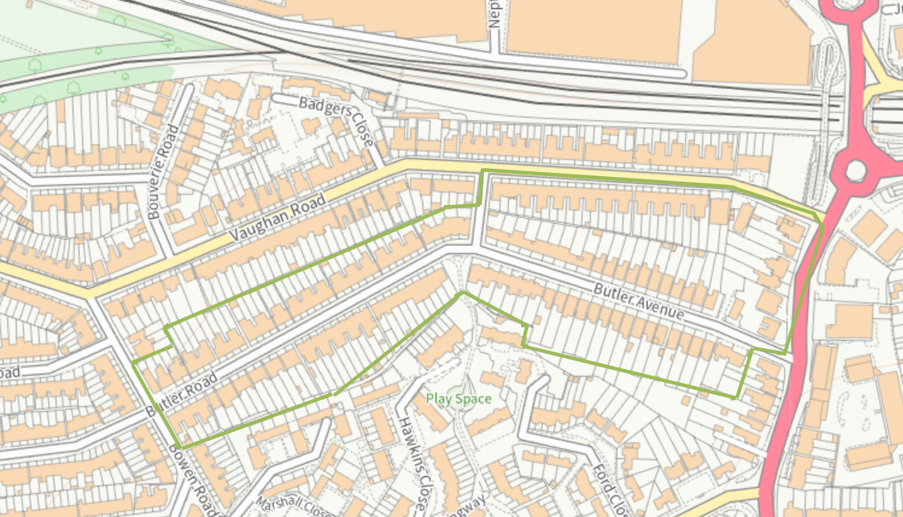

Map 2 - West Drive Gardens, Bellfield Avenue and numbers West Drive1- 41 (odd) and 2-36 (even), Harrow Weald
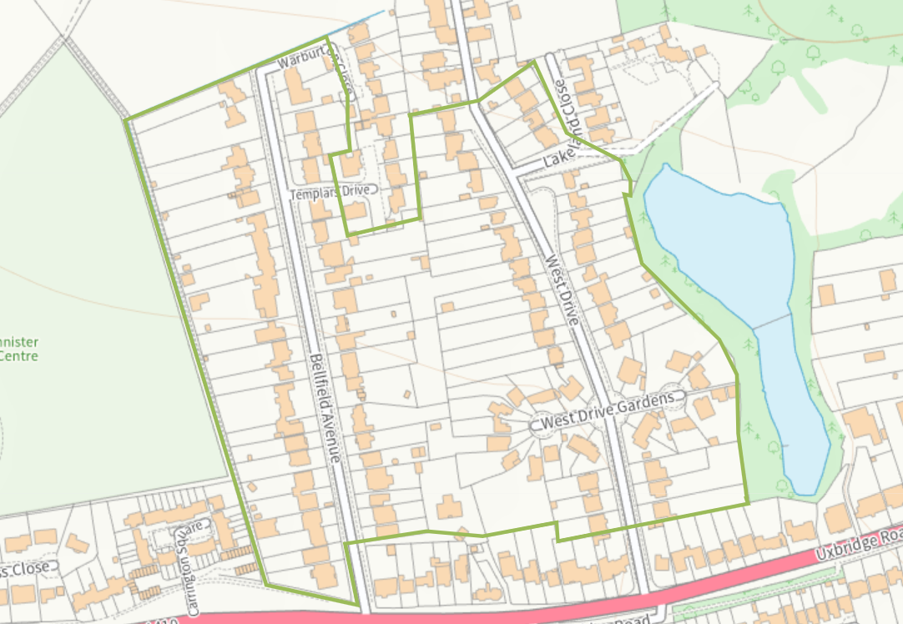
Map 3 - Suffolk Road, North Harrow
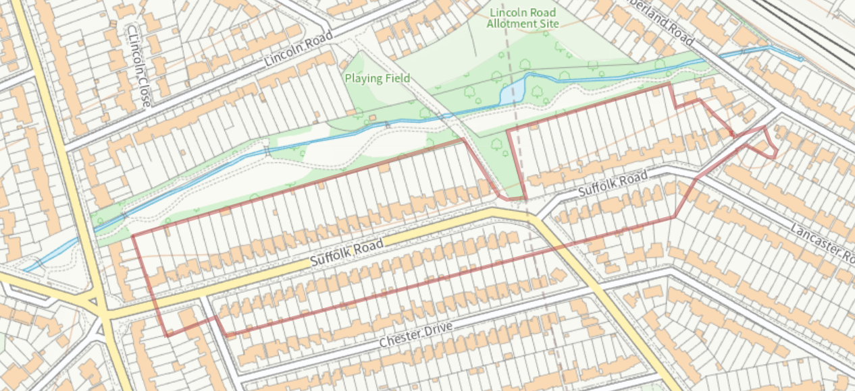

These criteria were originally agreed by the Development Control Committee on 31 August 1998 as the criteria to be adopted in Harrow.

